Class participant Sqls:

1. Create a view containing nation, firm, price, quantity, exchange rate, value, and yield.

**Query:**

create view temp1 as select a.natcode,a.natname,b.stkfirm,b.stkprice,b.stkqty,a.exchrate,(b.stkprice*b.stkqty) as value, (b.stkdiv/b.stkprice)*100 as yield From nation as a join stock as b on a.natcode=b.natcode ;

select * from temp1;

**Screenshot:**

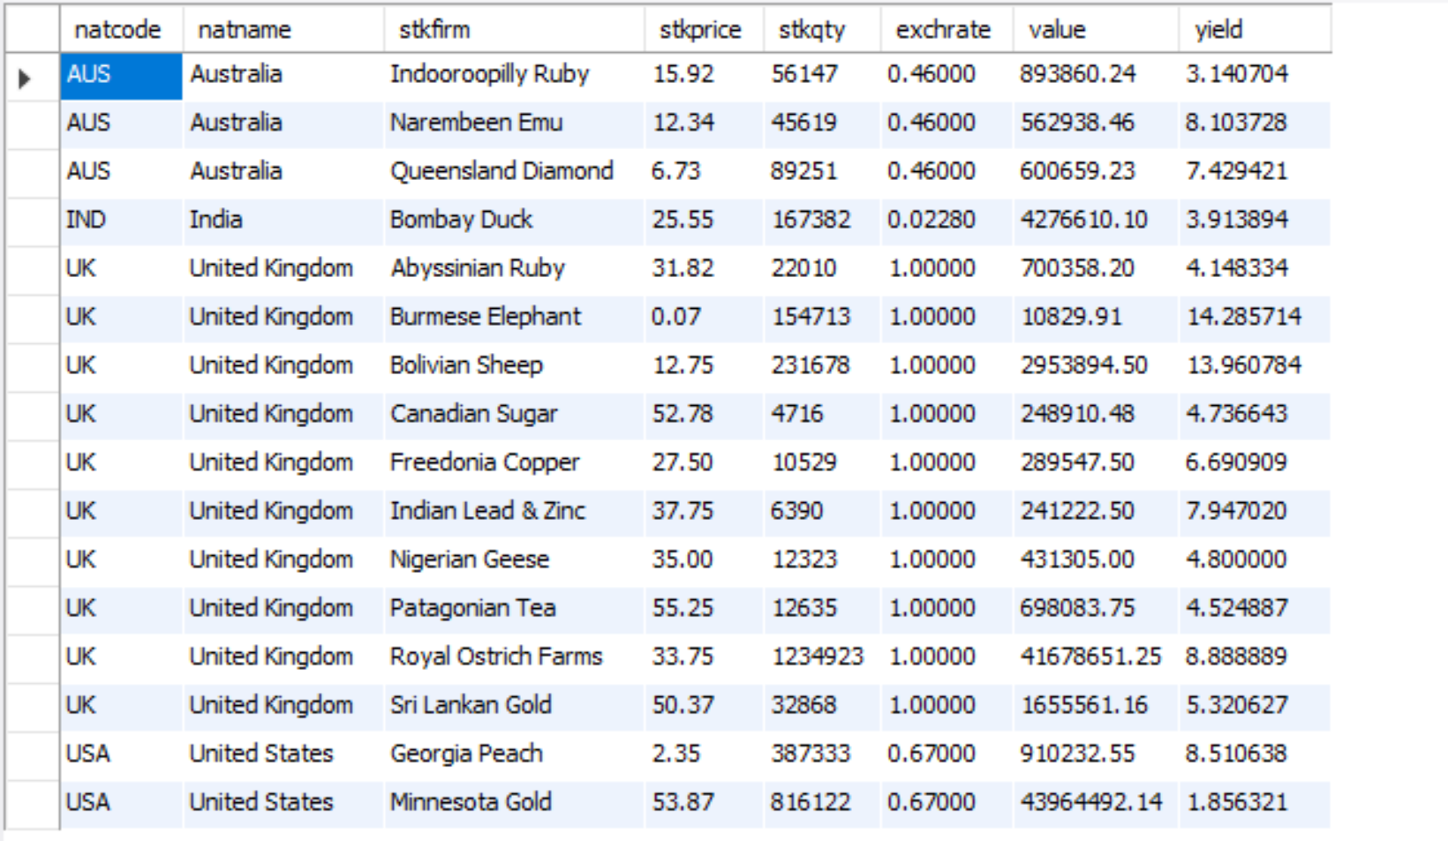

1. Report the minimum and maximum yield for each nation

**Query :**

select natname,max(yield),min(yield) from temp1group by natname;

**Screenshot :**

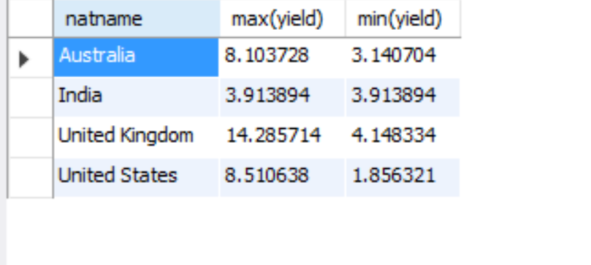

1. Report the nations where the average yield of stocks exceeds the average yield of all stocks

**Query:**

select natname,avg(yield) from temp1 group by natname having avg(yield) > (select avg(yield) from temp1);

**Screenshot:**

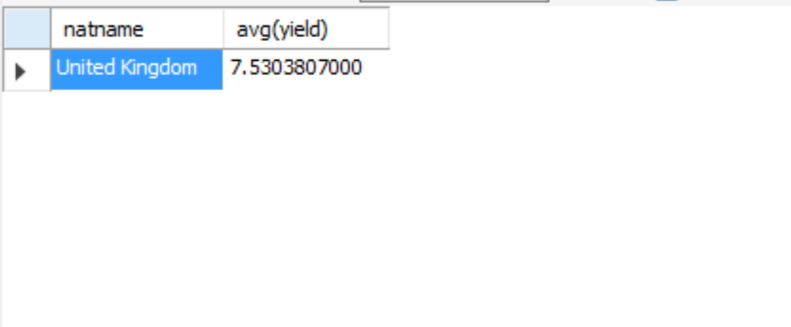

Write SQL based on Employee and Department tables described in Chapter 6

1. Find the departments where all the employees earn less than their boss.

**Query:**

select c.deptname from

(select deptname,count(*) as emp_count from emp group by deptname) as c

join

(select a.deptname,count(*) as emp_count_less_salary From emp as a join emp as b on a.bossno=b.empno where a.empsalary<b.empsalary group by a.deptname) as d on c.deptname=d.deptname where emp_count=emp_count_less_salary;

**Screenshot:**

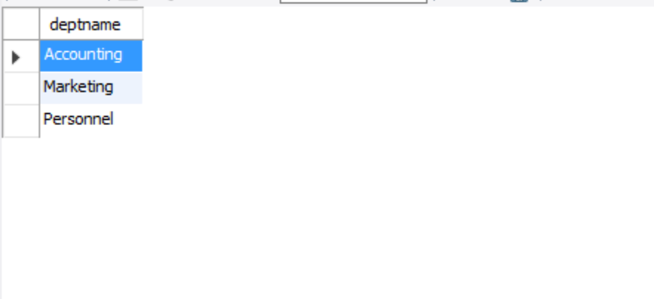5. Find the names of employees who are in the same department as their boss (as an employee)

**Query:**

select a.empno,a.empfname,a.deptname as emp_department,a.bossno,b.empfname as boss_name,b.deptname as boss_department From emp as a join emp as b on a.bossno=b.empno where a.deptname=b.deptname;

**Screenshot:**

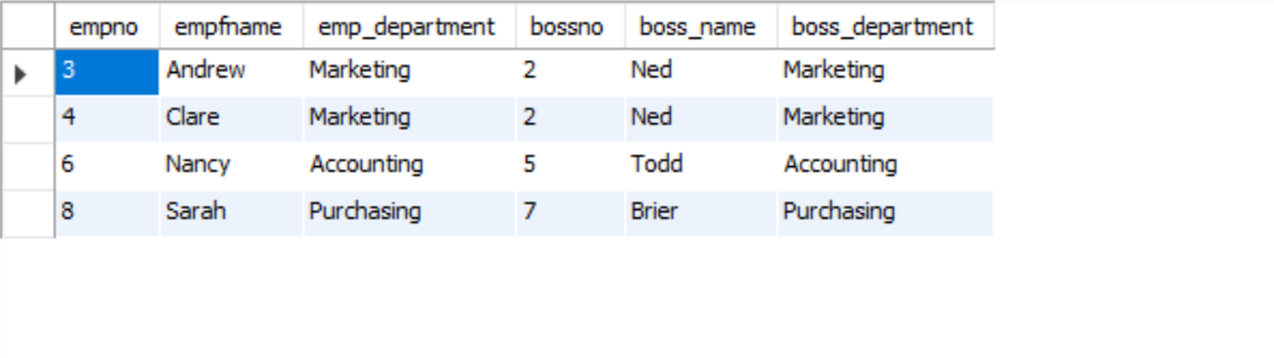

1. List the departments having an average salary greater than $25,000

**Query:**

select deptname,avg(empsalary) as avg_Salary from emp group by deptname having avg(empsalary)>25000;

**Screenshot:**

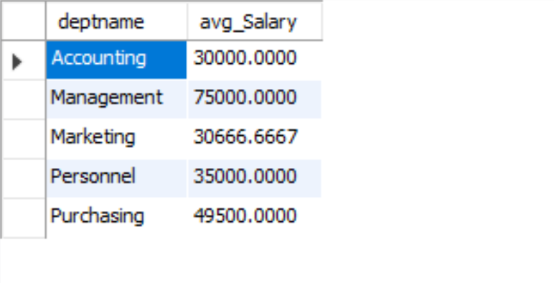

Write SQL to answer the following queries using the monarch table described in chapter 6

1. Who succeeded Victoria I?

**Query:**

select monname,monnum from monarch where premonname="Victoria" and premonnum="I"; **Screenshot :**

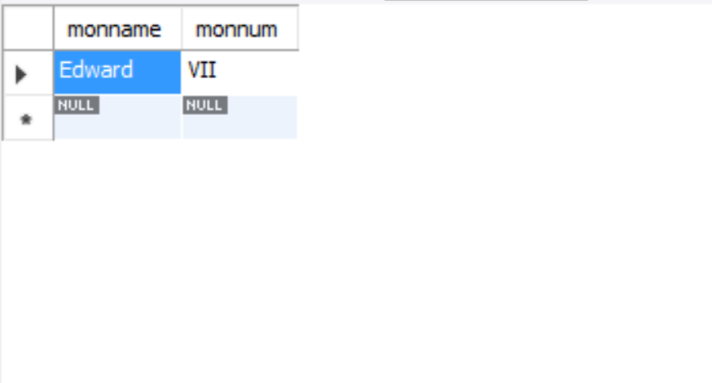

1. How many kings are there in the table?

**Query :**

select count(*) as total_no_of_Kings from monarch where montype='King' ;

**Screenshot:**

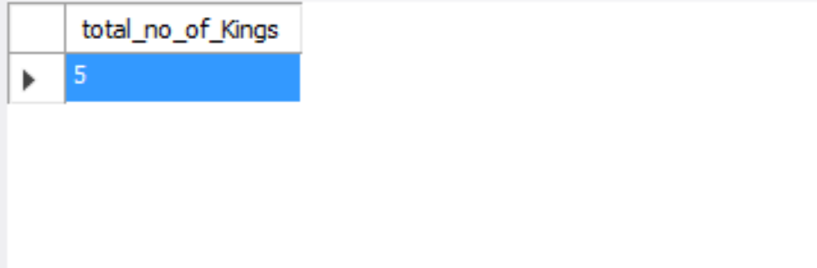9.          Which monarch had the shortest reign?

**Query:**

1. create view Monarch_view as select a.monname,a.monnum,a.premonnum,a.premonname,datediff(a.rgnbeg,b.rgnbeg) as difference from monarch as a left join monarch as b on a.Premonname=b.monname and a.premonnum=b.monnum order by a.rgnbeg asc;
2. select premonname,premonnum From Monarch_view where difference in (select min(difference) from Monarch_view);

**Screenshot :**

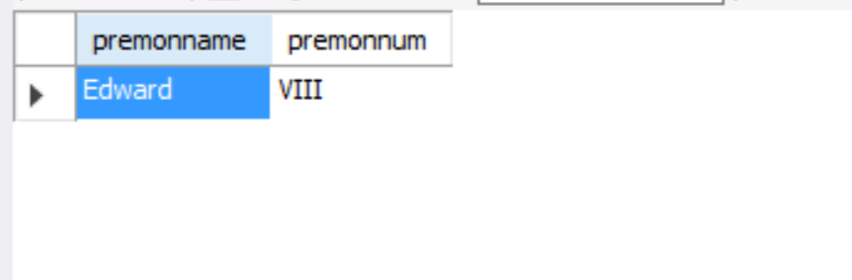10.     Using the ClassicModels database, write a correlated subquery to determine which employees work in the Paris office

**Query:**

select * From employees as a where 'Paris' = (select city from offices as b where a.officeCode=b.officeCode);

**Screenshot :**

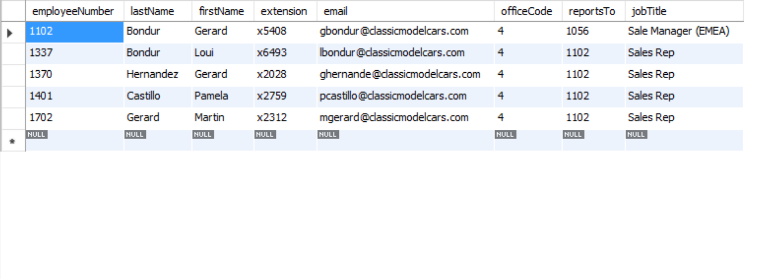

11.     Using the ClassicModels database, report the total value of payments for each customer to the nearest dollar and list in descending value

**Query:**

select a.customerNumber,a.customerName,round(sum(b.amount)) as total_Payment from customers as a left join payments as b on a.customerNumber=b.customernumber group by customerNumber order by total_Payment Desc;

**Screenshot :**

